  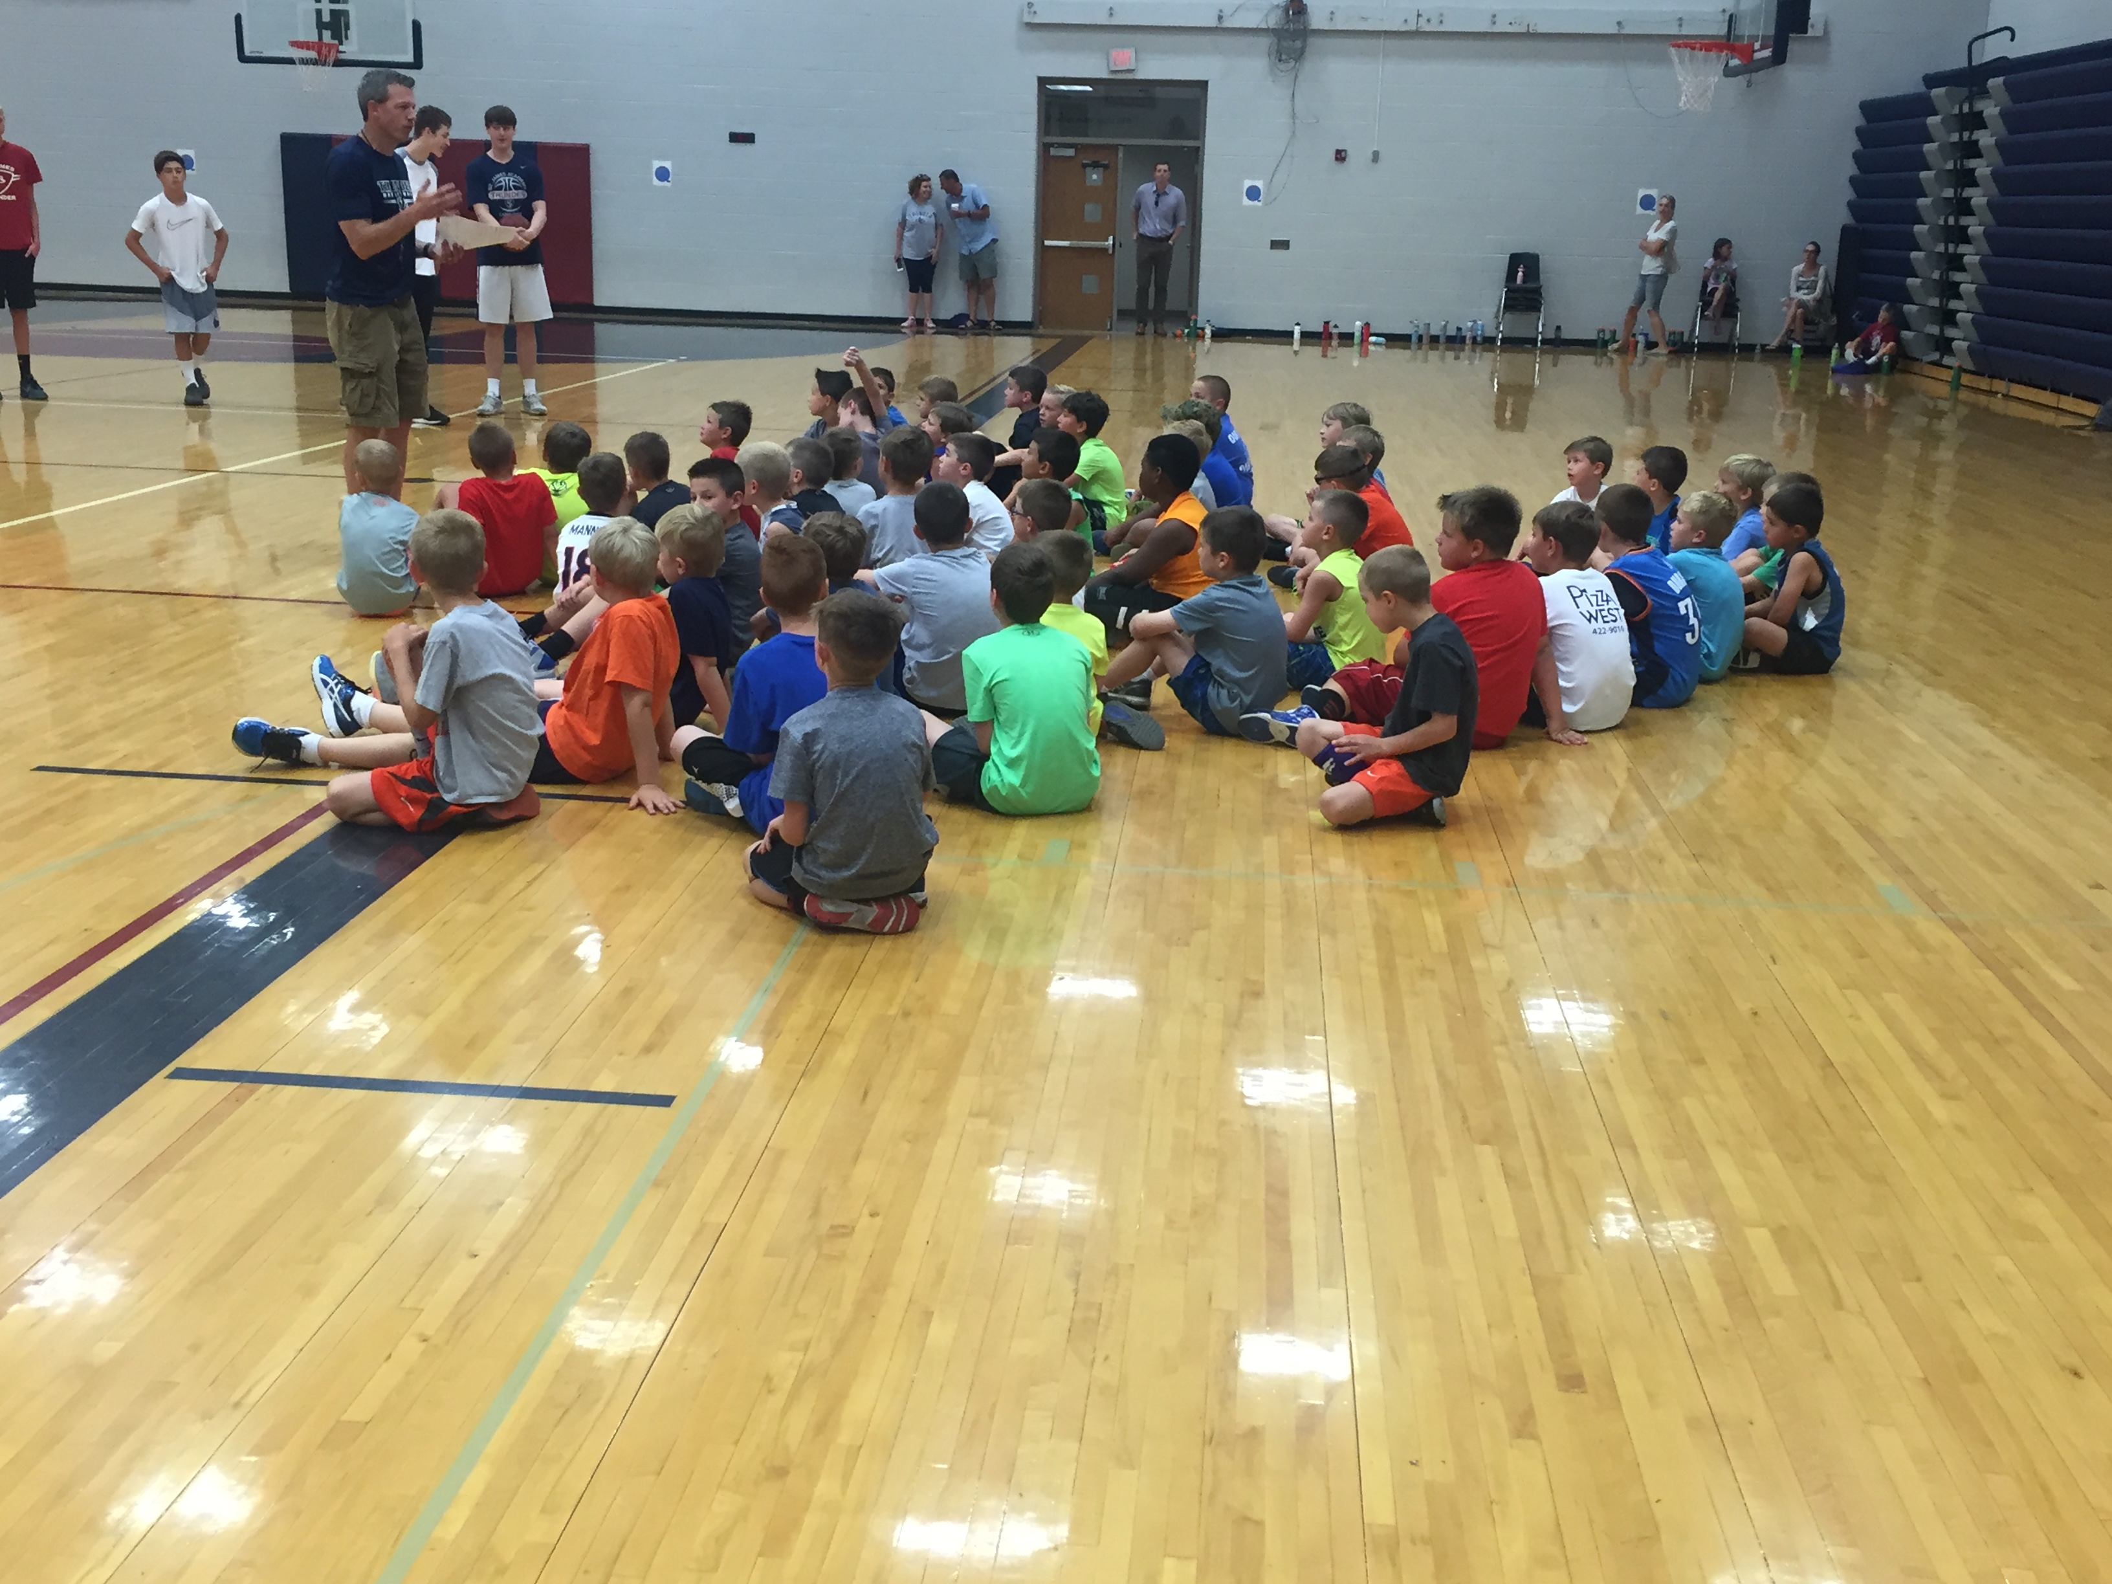
  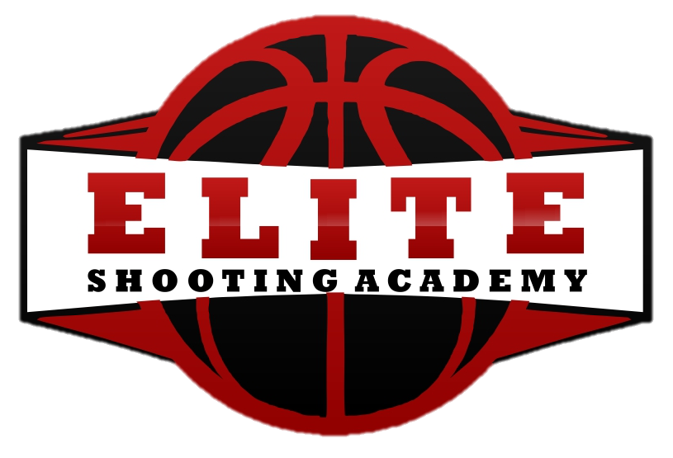
    - Elite Shooting Academy: Skills & Fundamentals clinic
  October 8-9th
  @ 68 Sports (11301 W. 88th St. – OVERLAND PARK)
  Get Ready for the 2016-17 CYO Basketball Season
  Coach Dohm and Coach Ferguson are pleased to present our skills and fundamentals clinic for the upcoming 2016-17 CYO basketball season. We will instruct players, grades 3-8th, to further enhance their development of shooting skills, dribbling fundamentals, and becoming a well-rounded offensive threat for their team. We will also provide players with a packet of individual drills/motivational handouts to get ready for the upcoming basketball season.
  Contact Us:
  E-mail: eliteshootingacademy@gmail.com Phone: 785.393.2432 Website: www.eliteshootingacademy.com
  CAMP INFO: $30 for 2 Days $20 -1 Day only
  SESSION 1:
  Grades: 3-4th
  Time: 1:00-2:00PM (25 Player Max)
  SESSION 2: Grades: 5-6th Time: 2:00-3:00PM (25 Player Max)
  G
  SESSION 3 (ELITE): Grades: 7-8th
  Time: 3:00-4:00PM (25 Player Max)
  Follow Us:
  
  REGISTRATION: Register Here

