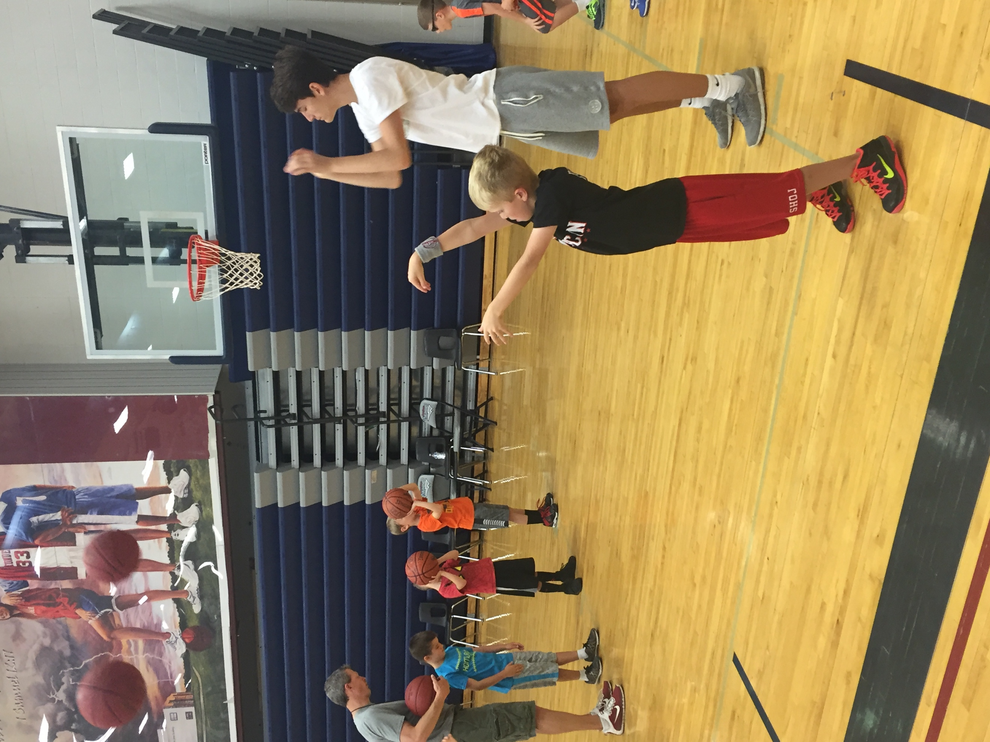


Final Tune-Up Clinic (Nov. 5th)
@ St. James Academy

Camp Information:
Session 1:
Grades: 1st-4th
Time: 9:00-10:00AM
Session 2:
Grades 5-8th
Time: 10:00-11:00AM
Session 3 (Elite Practice):
Grades: 7/8th (Invite Only)
Time: 11:00-12:00

Cost: $20 per player

Registration: Register Here

Get Ready for the 2016-17 Basketball Season with Coach Dohm and Coach Ferguson.

In this one-day camp we will be offering an opportunity for players of all ages to develop and fine-tune skills to prepare for their upcoming basketball seasons. This camp will be conducted to simulate a practice that a player might experience at the elementary and middle-school level and will be physical demanding, based on the player’s skill levels and ability. The camp will primarily focus on the following offensive skills. . .
- Reading & Making plays off Ball Screens
- Moving without the Basketball
- Scoring in Transition
- Breakdown Moves in the half-court
- Learn how to shoot FT’s Successfully from Coach Dohm (Stan Dohm has the KSHSAA single season FT% Record at 94.7%)
Elite Shooting Academy:

Contact Information Follow Us. . .


Website: www.eliteshootingacademy.com
E-Mail: eliteshootingacademy@gmail.com
Phone: 785.393.2432

